24CSI024L – DATA STRUCTURE AND ALGORITHMS

Hadhish R
25BAD029

Ex No:1a
Data:17.07.2026
IMPLEMENTATION OF LIST USING ADT
AIM
To implement the List Abstract Data Type (ADT) using an array in C, and to perform operations such as insertion, deletion, searching, updating, and displaying elements.
Pseudo Code
Algorithm: LIST_ADT
Begin
1. Initialize
size ← 0
2. Insert(item)
If size = MAX then
Print "List is Full"
Else
list[size] ← item
size ← size + 1
End If
3. Delete(item)
Search for item in the list
If item is found then
For each element after the item
Shift element one position to the left
End For
size ← size - 1
Else
Print "Item not found"
End If
4. Display()
If size = 0 then
Print "List is Empty"
Else
For i ← 0 to size - 1
Print list[i]
End For
End If
Program:
#include <stdio.h>
#define MAX 100
int arr[MAX];
int n = 0;
void insert()
{
int value;

printf("Enter value to insert: ");
scanf("%d", &value);

arr[n] = value;
n++;

printf("Element inserted successfully.\n");
}
void delete()
{
int pos, i;

printf("Enter position to delete: ");
scanf("%d", &pos);

if(pos < 1 || pos > n)
{
printf("Invalid position.\n");
return;
}

for(i = pos - 1; i < n - 1; i++)
{
arr[i] = arr[i + 1];
}

n--;

printf("Element deleted successfully.\n");
}
void update()
{
int pos, value;

printf("Enter position to update: ");
scanf("%d", &pos);

if(pos < 1 || pos > n)
{
printf("Invalid position.\n");
return;
}

printf("Enter new value: ");
scanf("%d", &value);

arr[pos - 1] = value;

printf("Element updated successfully.\n");
}
void display()
{
int i;

if(n == 0)
{
printf("List is empty.\n");
return;
}

printf("List Elements: ");

for(i = 0; i < n; i++)
{
printf("%d ", arr[i]);
}

printf("\n");
}

int main()
{
int choice;

do
{
printf("\n--- LIST ADT USING ARRAY ---\n");
printf("1. Insert\n");
printf("2. Delete\n");
printf("3. Update\n");
printf("4. Display\n");
printf("5. Exit\n");
printf("Enter your choice: ");
scanf("%d", &choice);

switch(choice)
{
case 1:
insert();
break;

case 2:
delete();
break;

case 3:
update();
break;

case 4:
display();
break;

case 5:
printf("Exiting...\n");
break;

default:
printf("Invalid choice.\n");
}

} while(choice != 5);

return 0;
}
OUTPUT:
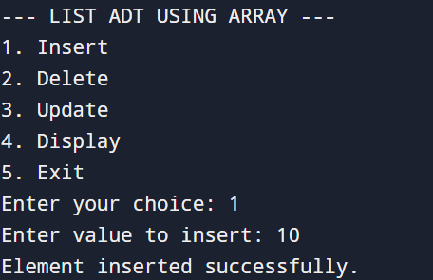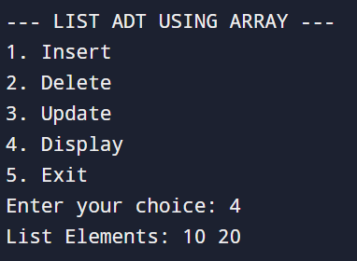
RESULT:
The List ADT was successfully implemented using an array in C. Operations such as insertion, deletion, searching, updating, and displaying were performed and verified to work correctly.

Ex No:1b
Date:17.07.2026
LINEAR SEARCH USING AN ARRAY ADT

AIM:
To implement Linear Search operation on a List Abstract Data Type (ADT) using an array in C.
Pseudo Code:
START
Create a structure List
data[MAX]
size
Procedure INITIALIZE(List L)
Set L.size = 0
End Procedure
Procedure INSERT(List L, item)
If L.size = MAX
Print "List is Full"
Return
End If

L.data[L.size] = item
L.size = L.size + 1
End Procedure
Procedure DISPLAY(List L)
If L.size = 0
Print "List is Empty"
Return
End If

Print "List Elements:"
For i = 0 to L.size - 1
Print L.data[i]
End For
End Procedure
Function LINEARSEARCH(List L, key)
For i = 0 to L.size - 1
If L.data[i] = key
Return i
End If
End For

Return -1
End Function
MAIN PROGRAM
Create List L
Call INITIALIZE(L)

Read n

For i = 0 to n - 1
Read item
Call INSERT(L, item)
End For

Call DISPLAY(L)

Read key

position = LINEARSEARCH(L, key)

If position ≠ -1
Print "Element found at index", position
Else
Print "Element not found"
End If

STOP
Program:
#include <stdio.h>
#define MAX 100
typedef struct
{
int data[MAX];
int size;
} List;
void initialize(List *L)
{
L->size = 0;
}
void insert(List *L, int item)
{
if (L->size == MAX)
{
printf("List is Full!\n");
return;
}

L->data[L->size] = item;
L->size++;
}
void display(List *L)
{
if (L->size == 0)
{
printf("List is Empty!\n");
return;
}

printf("List Elements: ");
for (int i = 0; i < L->size; i++)
{
printf("%d ", L->data[i]);
}
printf("\n");
}
int linearSearch(List *L, int key)
{
for (int i = 0; i < L->size; i++)
{
if (L->data[i] == key)
{
return i;
}
}
return -1;
}
int main()
{
List L;
initialize(&L);

int n, item, key;

printf("Enter number of elements: ");
scanf("%d", &n);

printf("Enter elements:\n");
for (int i = 0; i < n; i++)
{
scanf("%d", &item);
insert(&L, item);
}

display(&L);

printf("Enter element to search: ");
scanf("%d", &key);

int pos = linearSearch(&L, key);

if (pos != -1)
printf("Element found at index %d\n", pos);
else
printf("Element not found.\n");

return 0;
}
OUTPUT:
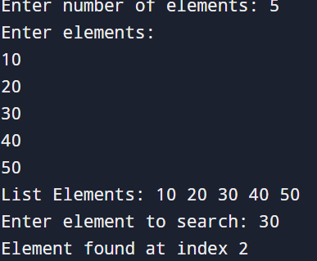
RESULT:
The List ADT using Linear Search was implemented successfully. The program correctly searched for the given element and displayed the appropriate result.

Ex No:1c
Date:17.07.2026
BINARY SEARCH USING AN ARRAY IN ADT
AIM:
To implement Binary Search using List ADT (Array) in C.
PSEUDO CODE:
START
Create a structure List
data[MAX]
size
Procedure INITIALIZE(List L)
L.size ← 0
End Procedure
Procedure INSERT(List L, item)
If L.size = MAX
Print "List is Full"
Return
End If

L.data[L.size] ← item
L.size ← L.size + 1
End Procedure
Procedure DISPLAY(List L)
Print "List Elements:"
For i ← 0 to L.size - 1
Print L.data[i]
End For
End Procedure
Function BINARYSEARCH(List L, key)
low ← 0
high ← L.size - 1

While low ≤ high
mid ← (low + high) / 2

If L.data[mid] = key
Return mid
Else If L.data[mid] < key
low ← mid + 1
Else
high ← mid - 1
End If
End While

Return -1
End Function
MAIN
Create List L
Call INITIALIZE(L)

Read n
For i ← 0 to n - 1
Read item
Call INSERT(L, item)
End For
Call DISPLAY(L)
Read key
position ← BINARYSEARCH(L, key)
If position ≠ -1
Print "Element found at index", position
Else
Print "Element not found"
End If
STOP
Program:
#include <stdio.h>
#define MAX 100
typedef struct
{
int data[MAX];
int size;
} List;
void initialize(List *L)
{
L->size = 0;
}
void insert(List *L, int item)
{
if (L->size == MAX)
{
printf("List is Full!\n");
return;
}

L->data[L->size] = item;
L->size++;
}
void display(List *L)
{
printf("List Elements: ");
for (int i = 0; i < L->size; i++)
{
printf("%d ", L->data[i]);
}
printf("\n");
}
int binarySearch(List *L, int key)
{
int low = 0;
int high = L->size - 1;

while (low <= high)
{
int mid = (low + high) / 2;

if (L->data[mid] == key)
return mid;
else if (L->data[mid] < key)
low = mid + 1;
else
high = mid - 1;
}

return -1;
}
int main()
{
List L;
initialize(&L);

int n, item, key;

printf("Enter number of elements: ");
scanf("%d", &n);

printf("Enter %d elements in sorted order:\n", n);
for (int i = 0; i < n; i++)
{
scanf("%d", &item);
insert(&L, item);
}

display(&L);

printf("Enter element to search: ");
scanf("%d", &key);

int pos = binarySearch(&L, key);

if (pos != -1)
printf("Element found at index %d\n", pos);
else
printf("Element not found.\n");

return 0;
}
OUTPUT:
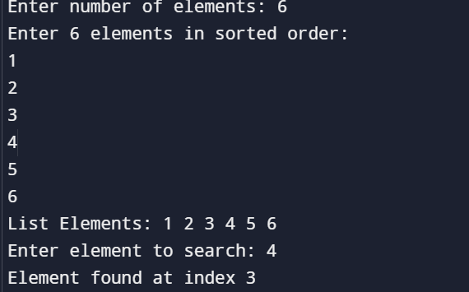
RESULT:
The Binary Search using List ADT was implemented successfully. The program correctly searched for the given element and displayed the appropriate result.

